REM- Reasonable Experiments Manager: User Guide

The Graph Generation System was designed to provide an interface for graph generation based on experiment data, using a client-server web interface.

The user can connect to a website, select a specific experiment, select a graph model and parameters, and display a graph.

The graphs are generated using the Bokeh library in python and are interactive- allowing zoom pan and save operations.

The system also allows to save/load/delete presets per experiment file, as well as an option to define your own plugin.

### Definitions:

**Experiment file** – a file containing the experiment data.

**Model** – a type of graph. e.g. – line, heat map, step etc.

**Input Parameters** – the input fields with the available options. Defined per model. (e.g. dropdown menu with all the machine names).

**Selected parameters** – the parameters selected by the user from the input parameter (e.g. 'time_stamp').

**Preset** – contains a name, the graph model, and the selected parameters (e.g. myline: line, time_stamp , performance, vm-1).

**Graph** – a visual representation of the selected model and input parameters.

**Plugin** – a python file which can be written by the user. Contains a definition for a graph model and input parameters.

Features:

An interface for graph generation from given experiments file.

* Interactive file explorer for easier experiment selection
* load preset: allow user to load a preset per experiment – selecting a preset from a list and generating a graph from it in a single click.
* Create preset: allow the user to create a new graph preset from available graph models (line,step, heatmap etc..).
* Save preset: allow the user to save the selected parameters as a preset for other users to use.
* Plugin system: allow user to define their own graph model by writing their own plugin in python.
* Allow user to define fields as 'filter by value', which upon selection will display an additional input field- allowing the user to select by value. Select-by-value Fields can define single or multiple selection.
* Generated graphs are also saved as a json (under the 'exports' sub-directory)
* Generated graphs are interactive on the browser- allowing zoom/pan etc and can be saved as a png.
* Database files (SQLite) holds the models and presets and experiments, and can be moved between machines to retain models/presets information.

### How to run:

To run the server, cd into the directory containing server.py and run ‘python server.py’

In the config file you can define the starting directory (for the file browser) and the port to use.

Proceed to the site accordingly (e.g. 'localhost:5000', or '192.0.0.5:6000' etc) using a modern browser (not IE)

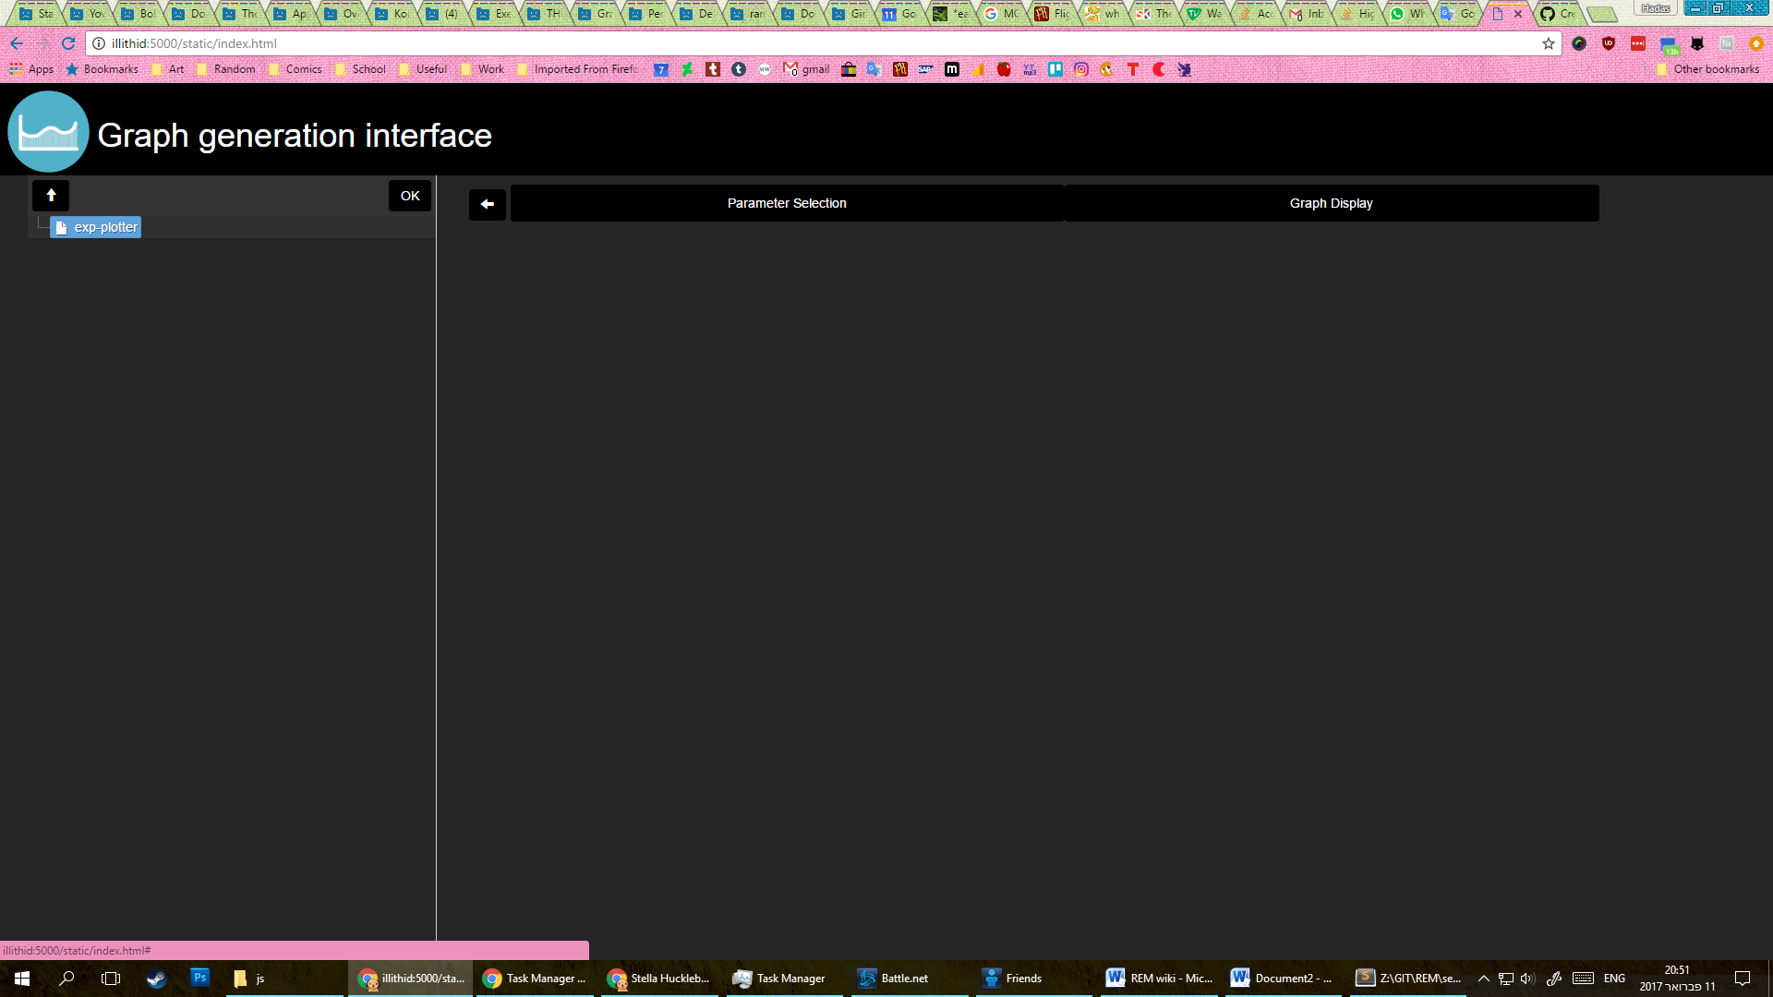Once the server is up, go to the website (as defined in the config file)  
The system will look like so:

## Section 1: The file explorer

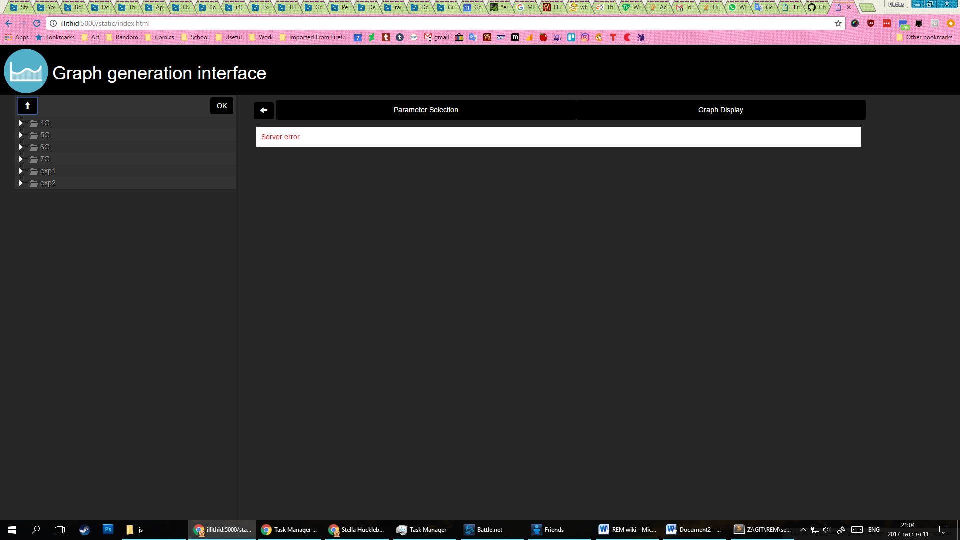

On the left side of the screen you'll see the file explorer.

Double-click a folder to see its contents, click the 'up' arrow to go up 1 directory.

Once you've located the exp file you wish to work with, click 'ok'

## Section 2: Parameter Selection

Once you've selected a file the system will move to the parameter selection tab.

There you can either create your own preset, or load an existing one.

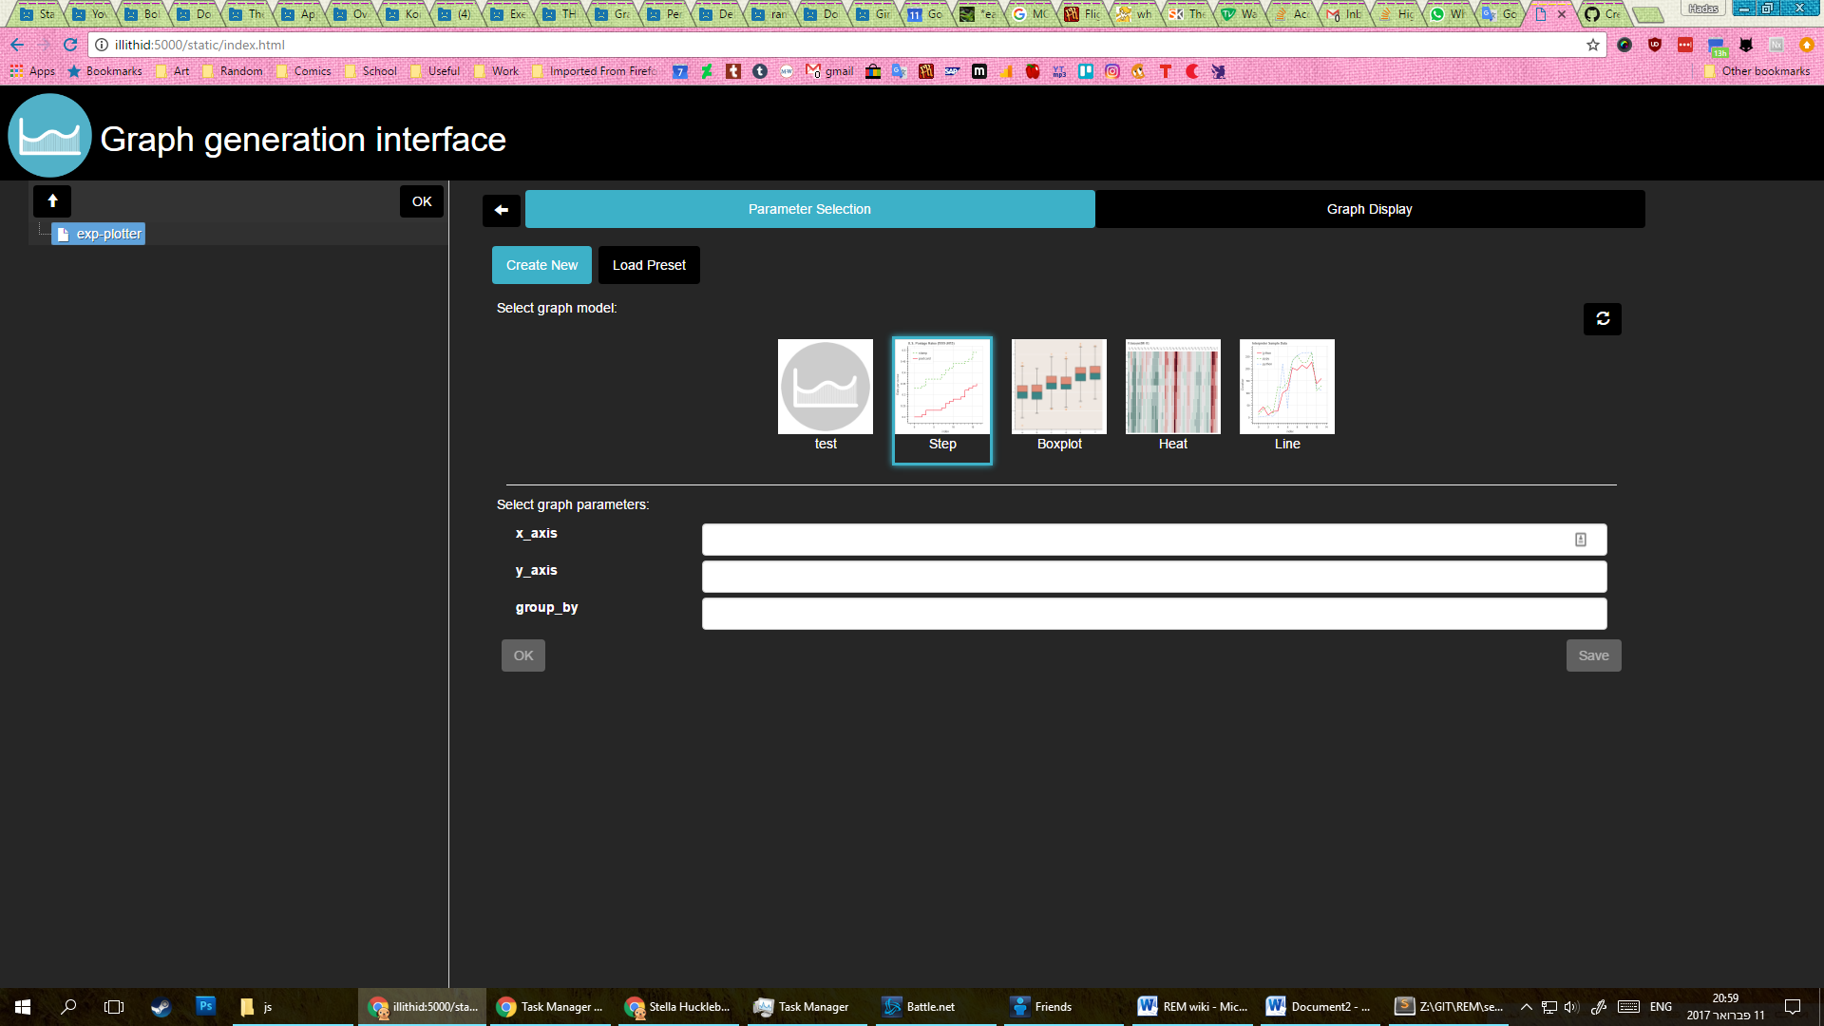

### Section 2.1 : Create new

'Create New' will display the current plugins the system has.

The plugins define a graph model and input parameters.

Select the graph model to view to parameters it needs.

You can then either click 'Ok' to generate the graph and view it, or save the selected parameters and model as a new preset.

#### Section 2.1.1: Save

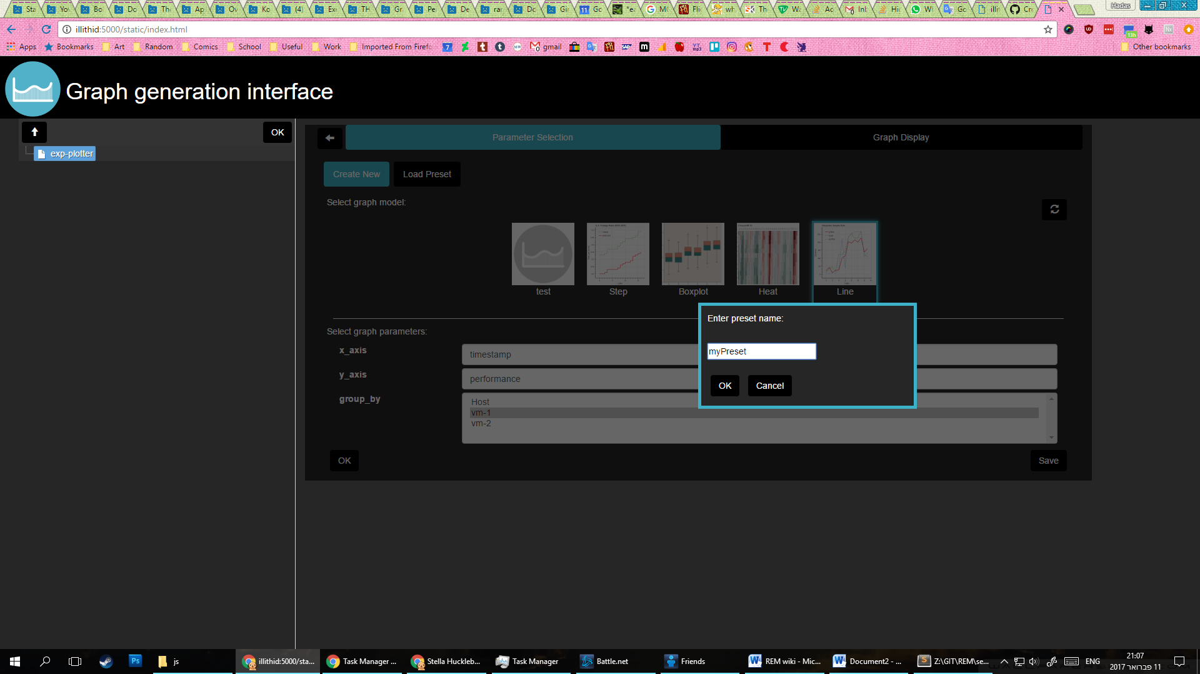

If you select 'save' a window will pop up where you can define your preset name – note! The name are unique, so if you select a name that already exists it will overwrite the existing one.

### Section 2.1 : Load

The load tab allows you to quickly select saved presets and load them to graph display.

## 

## Section 3: Graph Display

Upon selecting an existing preset (from load) or selecting new graph parameters (from create) you will be transferred to the Graph Display tab.

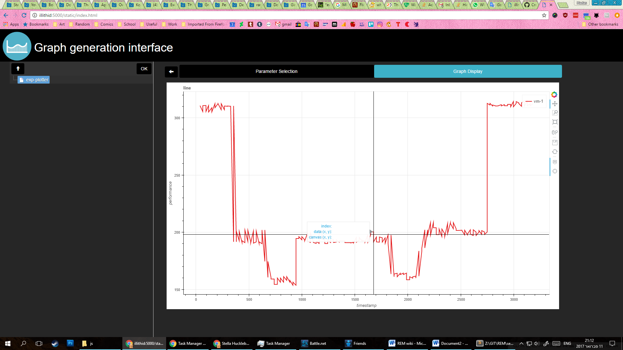

Here you can view an interactive version of the graph, along with options to pan, zoom, display data on hover and save as image.